**Sprint Review and Retrospective**

By: Ardon, Concepción

22 - Feb - 18

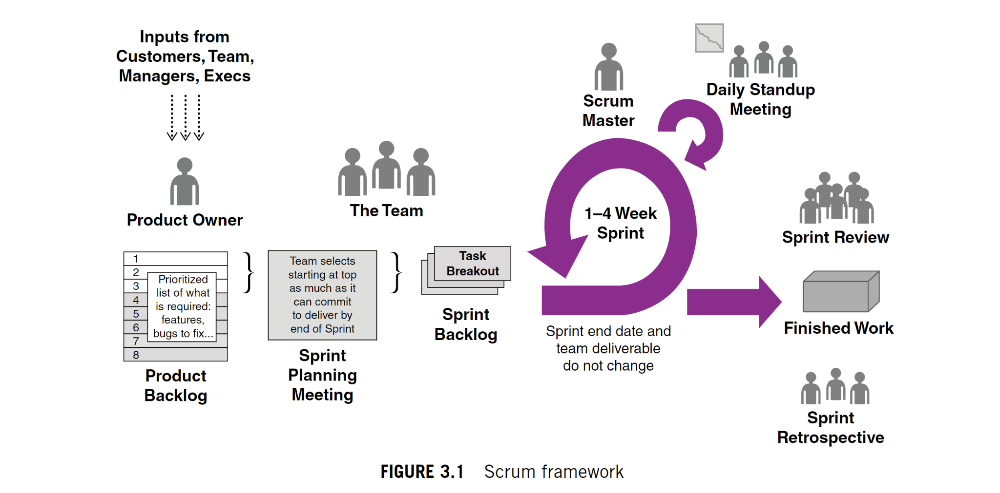

**Scrum-agile Team**

Product Owner - Our product owner contributed to the success of the SNHU Travel project by communicating and envisioning what the SNHU Travel management has in mind. The product owner created and prioritized the Product Backlog. The product owner also explained to the team the changes that were made and how our team was going to incorporate does changes into the original project. Our product owner maximizes the value of the product and the work of the development team. Without the product owner our communication with the company would have been a disaster since most of us don’t have any product owner skills/training.

Scrum Master - Our scrum master helped by assembling the agile team, ensuring effective Product Backlog management, Facilitating Scrum events and more. Our scrum master helped the development team create high-value products. The scrum master met with the scrum team to create our agile team charter, and schedule the Scrum events like Sprint Planning, Daily Scrum, Sprint Review, Retrospective, and Backlog Refinement. The scrum master also helped remove any challenges that were slowing the production of the development team’s. During a Scrum meeting the Scrum master helped clarified if the changes would affect the deadline. Without the scrum master our meetings would not be followed in an agile approach, and it would be disorganized.

Development Team - Our development team consist of a tester and developer. Our tester helps define the acceptance criteria and acceptance tests. The tester executes the test and analyzes results. The tester collaborates with the team to resolve any issues and defects in the product. Any ambiguity found in the code and user stories can be clarified by the tester. After the changes were announced the tester updated the test cases. Our developer collaborated with the team to produce just enough designs in order to have room to iterate. The developer participated in the peer reviews and developed and designed code according to the solid software engineering practices. The Development Team's main responsibilities are to complete work sprints according to the Product Owner's requirements, which are coordinated by the Scrum Master. The Daily Scrum is a regular standup meeting used to convey project progress to colleagues and the Scrum Master.

A Scrum-agile approach to the SDLC helped each user stories come to completion by meeting simplifying the definition of the requirements in a language that can be easily understood by both developers and users. For example, one of the user stories indicated that the user wants to be able to set a price range when looking for a vacation package. The developer made sure to meet does needs by adding a price range filter for the user. Another example would be when the users wanted a custom list based on their previous travel or profile. Our development team work on developing a list made by pulling the data from previous travels or profile that would appear on the user page. With Scrum-agile, our team was able to complete the SNHU Travel project by significantly increasing productivity and reducing time to benefits as compared to a waterfall process. It also gives the Scrum team adaptability to the requirements that are changing fast, and helps create a product that coordinates with SNHU Travels objectives. In our second meeting we had changes that were announced by the product owner and the team was able to adapt to the requirement made by the client. During the daily scrum meetings I am able to communicate what I have achieved, what needs to be done, and discussing my impediments with the team. I also discuss the need to collaborate with other team members. Later after the meeting the team can meet up and talk about anything they have in mind with others. Daily scrum meetings are very important key to the team in order to improve communication, identify any impediments, promote fast decision-making, and necessarily terminating the need for other meetings. Our Scrum team uses the VersionOne organizational tool to fully engage all team members in the process, be able to update progress in real-time and quickly view status and issues (information radiators), scale projects to an enterprise level, and provide a standardized way of reporting across the project. The scrum-agile principles help our team embrace helpful variability, keep options open, organize workflow for fast feedback, adapt to real-time information and replan, and more. For example, during the last meeting the client requested some changed to be done. Our team had an agile mindset and was ready to adapt to the new changes being incorporated.

The pros to Scrum-agile Approach:

* The teams are able to complete project deliverables efficiently and quickly
* Time and money are effectively used
* Testing and coding are conducted during sprint reviews
* Scrum meetings provide the team with clear visibility
* Being agile, Scrum incorporates feedback from customers and stakeholders
* During daily scrum meetings, the individual efforts of each team member are evident
* Short sprints make it much easier to make changes based on feedback

The cons to Scrum-agile Approach:

* Scrum often leads to scope creep, due to the lack of a definite end-date
* Adopting the Scrum framework in large teams is challenging
* In the absence of commitment and cooperation, projects are highly likely to fail
* Only an experienced team can ensure the success of the framework
* Team members sometimes get frustrated by daily meetings
* It has a great impact on the project if a team member leaves in the middle of the project
* It is difficult to implement quality until the team conducts aggressive testing

Furhtomore, I believe we can get pass the disadvantages of an agile approach. This determines that my decision is to use the Scrum-agile approach because it suits the SNHU Travel development project more.

Work Cited

Chandana. (2022, January 12). *Scrum project management: Advantages and disadvantages*. Simplilearn.com. Retrieved February 21, 2022, from https://www.simplilearn.com/scrum-project-management-article

*What is a daily scrum?* Scrum.org. (n.d.). Retrieved February 21, 2022, from https://www.scrum.org/resources/what-is-a-daily-scrum

Charles G. Cobb. (2015). The Project Manager’s Guide to Mastering Agile : Principles and Practices for an Adaptive Approach. Wiley.